
MAHATMA EDUCATION SOCIETY’S
PILLAI COLLEGE OF ARTS, COMMERCE & SCIENCE
(AUTONOMS) NEW PANVEL

PROJECT REPORT STATISTICAL METHODS AND TESTING OF HYPOTHESIS
SURVEY ON STUDENT LEARNING, LIFESTYLE & AI TOOL USAGE

IN PARTIAL FULFILLMENT
BACHELOR OF SCIENCE COMPUTER SCIENCE

SEMESTER II– 2025-26

PROJECT GUIDE
PROFESSOR. SABITHA PRAVEEN

SUBMITTED BY
KRISHNA KAMLESH SINGH
ROLL NO. 1400
INDEX

CERTIFICATE
INTRODUCTION
NEED OF THE PROJECT
OBJECTIVES OF THE PROJECT
METHODOLOGY
DATA LOADING & CLEANING
VISUAL REPORT (CHARTS)
PROBABILITY DISTRIBUTIONS
HYPOTHESIS TESTING (COMMUNICATION)
SOURCE CODE
SWOT
CONCLUSION

INTRODUCTION
The integration of Artificial Intelligence (AI) into higher education represents one of the most transformative shifts in modern pedagogy. This research project, titled "Survey on Student Learning, Lifestyle, and AI Tool Usage," serves as a core requirement for the Semester 2 curriculum in Statistical Methods and Testing of Hypothesis. It explores the delicate balance between academic discipline, personal well-being, and the rapid adoption of Generative AI tools like ChatGPT and Gemini. By converting qualitative student experiences into quantitative data, this study examines how technology influences traditional learning habits and lifestyle metrics.
The data for this study was meticulously gathered through primary research using a digital Google Form survey. This instrument consisted of 12 to 15 targeted questions designed to capture a multi-dimensional view of the student experience. A total of 86 genuine responses were collected, forming a robust dataset that includes demographic details, weekly study hours, sleep patterns, and exercise habits. The survey focused heavily on AI interactions, measuring not only the frequency of use but also its perceived impact on learning efficiency and stress reduction.
Upon completion of the survey, the data was exported in CSV format for analysis in the R environment. Rigorous data cleaning was performed using string manipulation functions like gsub and as.numeric to handle range-based responses (such as "4–7 hours"). This ensured that the raw text was successfully converted into precise numeric values suitable for computational modeling.
The analytical framework utilizes both descriptive and inferential statistics to validate research objectives. Probability distributions, including Binomial, Poisson, and Normal distributions, were applied to model AI adoption rates and study patterns. Furthermore, the project employs advanced hypothesis testing—such as t-tests, Z-tests, Chi-Square tests, and ANOVA—to determine if factors like gender or academic program significantly influence student performance and AI usage. Ultimately, this project provides a scientifically grounded perspective on the modern student’s academic ecosystem.

NEED OF THE PROJECT
The modern educational environment is undergoing a paradigm shift due to the rapid accessibility of high-speed internet and advanced computational tools. Traditional study habits, which once relied solely on textbooks and library research, are now being supplemented—and in some cases, replaced—by Generative Artificial Intelligence. However, this transition raises significant questions about student well-being and academic integrity.
There is a critical need to investigate whether the use of AI actually "buys back" time for students to improve their lifestyle—such as getting more sleep or exercising—or if it simply changes the nature of academic stress. Many assumptions are made about how AI affects learning, but without statistical evidence, these remain anecdotal. This project is necessary to provide a quantitative baseline that distinguishes between perceived efficiency and actual statistical significance. By analyzing 86 genuine responses, this study addresses the gap in understanding how technological intervention correlates with biological needs like sleep and academic requirements like self-study

OBJECTIVES OF THE PROJECT
The primary goal of this research is to move beyond simple observation and apply rigorous statistical testing to student data. The specific objectives are as follows:
- To Analyze Distribution Patterns: To identify the common trends in student age, study duration, and sleep cycles using Descriptive Statistics and Normal Distribution modeling.
- To Measure AI Adoption and Frequency: To calculate the probability of AI tool usage within the student community using Binomial and Poisson distributions.
- To Evaluate Academic Efficiency: To perform Hypothesis Testing (t-tests) to determine if AI tools significantly improve learning efficiency beyond a neutral baseline.
- To Identify Demographic Variations: To examine if study habits and AI reliance differ significantly based on Gender or Academic Program using Two-Sample tests and ANOVA.
- To Test Independence of Variables: To use Chi-Square tests to see if there is a relationship between a student’s lifestyle choices (like exercise) and their academic demographic.
- To Validate Target Benchmarks: To conduct Z-tests to compare student self-study hours against the academic standard of 10 hours per week.

METHODOLOGY
The methodology of this research project follows a structured scientific approach, transitioning from primary data collection to advanced computational analysis. The process was designed to ensure that the findings are both statistically valid and representative of the student population.

Research Design
The study employs a quantitative research design. Unlike qualitative studies that focus on open-ended interviews, this project prioritizes measurable data points—such as hours of sleep, age, and Likert-scale ratings—to allow for the application of mathematical models and hypothesis testing. This design was chosen specifically to satisfy the requirements of "Statistical Methods," where the objective is to find patterns and correlations within a numerical framework.

Data Collection Instrument
The primary tool for data collection was a Structured Digital Questionnaire developed via Google Forms.
- Survey Composition: The survey consisted of 12 to 15 questions, categorized into three segments:
  - Demographics: Age, Gender, and Academic Program.
  - Lifestyle: Weekly study hours, nightly sleep duration, and exercise frequency.
  - AI Integration: Usage status, frequency of use, and subjective impact on efficiency and stress (measured on a scale of 1 to 5).
- Sampling Technique: A convenience sampling method was used, targeting active students across various programs (BSc CS, BSc IT, BCA, BTech, etc.) to ensure a diverse dataset. A total of 86 genuine responses were obtained.

Data Processing and Cleaning
Once the responses were collected, the data was exported in CSV format. Raw survey data often contains "noise" that can interfere with statistical functions. Therefore, a rigorous cleaning process was implemented in the R environment:
- Numeric Conversion: Many students provided range-based answers (e.g., "4-7 hours"). The R script utilized gsub and regular expressions to identify and extract the first numeric value from these strings to create a continuous numeric variable.
- Normalization: Categorical data, such as Gender and AI Usage ("Yes"/"No"), were converted into factors. This allows the R software to recognize them as distinct groups for comparison in tests like ANOVA and t-tests.
- Handling Missing Values: The na.rm = TRUE parameter was utilized across all calculations to ensure that any incomplete responses did not skew the final averages or test statistics.

Statistical Framework
The methodology concludes with the application of specific statistical tests to validate the research hypotheses:
- Descriptive Statistics: Calculation of Mean and Standard Deviation to establish the "average" student profile.
- Distribution Modeling:
  - Binomial Distribution: Used to determine the probability of AI tool adoption.
  - Poisson Distribution: Used to model the occurrence of study hours over a fixed interval.
  - Normal Distribution: Applied to Age to check for a bell-curve distribution within the sample.
- Inferential Testing: * t-Tests: Used to compare the means of two groups (e.g., Male vs. Female study habits).
  - Z-Tests: Used to compare the sample mean against a known population parameter (e.g., a target of 10 study hours).
  - Chi-Square Test: Employed to test the "Goodness of Fit" and the "Independence" between variables like Gender and AI Usage.
  - ANOVA (Analysis of Variance): Used to compare the means of more than two groups simultaneously, specifically looking at how different Academic Programs affect study behavior.

Tools Used
- Google Forms: For the creation and distribution of the survey.
- R Programming Language: The primary engine for all data manipulation, probability modeling, and hypothesis testing.
- R Console: Used for real-time data processing and generating the final analytical report.

DATA LOADING & CLEANING
The foundation of any statistical analysis lies in the integrity of the data. In this project, the data loading and cleaning phase is the most critical technical step, as it transforms "raw" survey responses into a "tidy" format that R can process mathematically. Survey data, especially from platforms like Google Forms, often contains text-based responses for numerical questions (e.g., "18 years" or "4–7 hours"), which prevents direct calculation until properly cleaned.

Code Breakdown and Technical Explanation
The following R code was implemented to prepare the dataset for hypothesis testing:
# 1. DATA LOADING
data = read.csv(file.choose())

- Methodology: The read.csv() function is used to import the dataset into R's memory. By nesting file.choose() inside it, the script opens a standard Windows/Mac file explorer window. This allows the user to manually select the downloaded "Survey Responses" CSV file without needing to type out a complex file path.

# 2. NUMERIC EXTRACTION USING REGULAR EXPRESSIONS (REGEX)
data$Age = as.numeric(gsub("([0-9]+).*", "\\1", data[,3]))
data$StudyHours = as.numeric(gsub("([0-9]+).*", "\\1", data[,6]))
data$Sleep = as.numeric(gsub("([0-9]+).*", "\\1", data[,7]))

The Problem: In the survey, questions regarding Age, Study Hours, and Sleep were often answered in ranges (e.g., "4–7 hours") or included text. R sees "4–7" as a character string, not a number.
The Solution: * gsub("([0-9]+).*", "\\1", ...): This is a powerful pattern-matching command. The ([0-9]+) part looks for the first group of digits it finds. The .* tells it to ignore everything that follows. The \\1 tells R to "keep only that first group of digits."
- as.numeric(): Once the text is stripped away and only the digits remain, this function converts the character string into a mathematical number.
- Result: "4–7 hours" is successfully cleaned and stored as the number 4.
# 3. TYPE CONVERSION
data$AI_Efficiency = as.numeric(data[,16])
data$AI_Stress = as.numeric(data[,17])
data$Gender = as.factor(data[,4])
- Likert Scales: Columns 16 and 17 contain the 1–5 scale ratings. Ensuring these are strictly numeric allows us to calculate the Mean Efficiency and Mean Stress reduction.
- Categorical Factors: The Gender column (column 4) is converted into a Factor using as.factor(). In R, a factor is a specific data type used to represent categories. This is essential for our Two-Sample t-tests and ANOVA, as it tells the software how to group the students (e.g., comparing "Male" group vs. "Female" group).

# 4. DESCRIPTIVE SUMMARY
cat("\n[1] DATA SUMMARY\n")
print(summary(data[, c("Age", "StudyHours", "Sleep", "AI_Efficiency", "AI_Stress")]))
- Verification: Finally, the summary() function provides a "health check" of the cleaned data. It calculates the Minimum, Maximum, Median, and Mean for every variable. This allows us to spot any outliers or errors immediately before proceeding to the hypothesis testing phase.

Importance of this Step
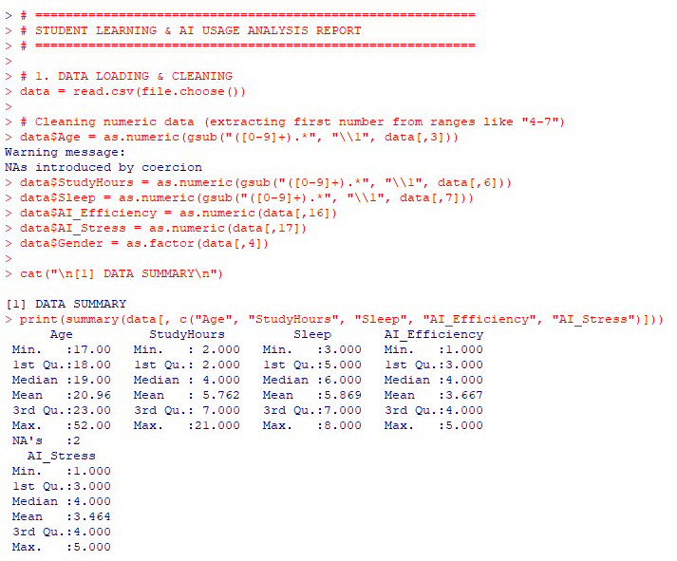
Without this specific cleaning process, R would return an error of "non-numeric argument to binary operator" whenever we tried to calculate a mean or run a t-test. By using Regular Expressions (Regex), we ensure that we don't lose valuable data just because it was formatted as a range, thereby maintaining a robust sample size of 86 responses.

VISUAL REPORT (CHARTS)
Visualizations are essential in statistical projects as they allow us to see patterns, trends, and outliers that might be hidden in raw numbers. In this section, we use R’s base graphics system to create a "Dashboard" view of the survey results.

2. VISUAL REPORT (CHARTS)
# ==========================================================
# Set up a layout for multiple charts
par(mfrow=c(2,2))

# Chart 1: Distribution of AI Usage
ai_usage_table = table(data[,11])
barplot(ai_usage_table, col=c("tomato", "lightblue", "lightgreen"),
main="Do Students Use AI?", xlab="Response", ylab="Count")

# Chart 2: Sleep vs Study Hours
plot(data$StudyHours, data$Sleep, pch=19, col="darkblue",
main="Sleep vs. Study Hours", xlab="Study Hours", ylab="Sleep Hours")
abline(lm(data$Sleep ~ data$StudyHours), col="red", lwd=2) # Add trend line

# Chart 3: Study Hours by Gender
boxplot(StudyHours ~ Gender, data=data, col=c("pink", "skyblue"),
main="Study Hours: Male vs Female", xlab="Gender", ylab="Hours")

# Chart 4: AI Impact (Efficiency vs Stress Reduction)
plot(data$AI_Efficiency, data$AI_Stress, jitter=1, pch=18, col="darkgreen",
main="Efficiency vs Stress Reduction", xlab="Efficiency Scale", ylab="Stress Reduction Scale")

# Reset layout
par(mfrow=c(1,1))

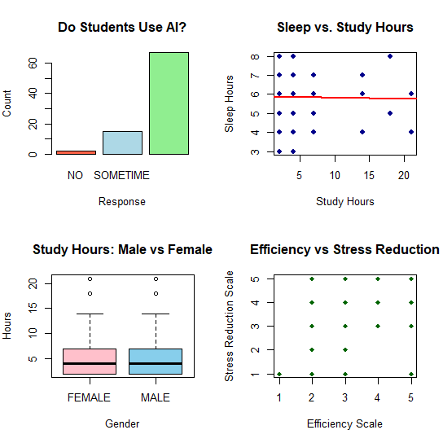

PROBABILITY DISTRIBUTIONS
This section of the code applies theoretical models to your survey data to predict behaviors and identify patterns within the student population. Here is a short explanation of each part:

1. Binomial Distribution (AI Usage)
- Purpose: Used for "Yes/No" outcomes. Since a student either uses AI or they do not, this is a classic binomial scenario.
- The Code: It counts how many students answered "YES" (ai_yes) and divides it by the total number of students (n) to find the probability p.
- Goal: It defines the "success rate" of AI adoption. It allows you to calculate the probability of finding a specific number of AI users in any future group of students.
# --- Binomial (AI Usage) ---
ai_yes = sum(toupper(data[,11]) == "YES", na.rm=TRUE)
n = nrow(data)
p_val = ai_yes / n
cat("Binomial: Probability of a student being an AI user:", round(p_val, 4), "\n")
Binomial: Probability of a student being an AI user: 0.7976

2. Poisson Distribution (Study Hours)
- Purpose: Used for "counts" or events happening over a period of time. Here, we treat "study hours per week" as the occurrence.
- The Code: It calculates the average study hours (avg_study) and uses the dpois() function.
- Goal: It calculates the probability of a student studying exactly 5 hours a week. It helps you understand how likely it is for a student to hit a specific numeric target based on the group's average.
avg_study = mean(data$StudyHours, na.rm=TRUE)
prob_5_hrs = dpois(5, avg_study)
cat("Poisson: Prob. of a student studying exactly 5 hours:", round(prob_5_hrs, 4), "\n")
Poisson: Prob. of a student studying exactly 5 hours: 0.1665

3. Normal Distribution (Age)
- Purpose: Used for variables that naturally cluster around an average, creating a "Bell Curve." Age in a university setting usually follows this pattern.
- The Code: It calculates the Mean (the center of the curve) and the Standard Deviation (how wide the curve is).
- Goal: It establishes the "Standard Profile" of your respondents. By knowing the Mean and SD, you can mathematically define what age is considered "typical" or "rare" for your survey group.
avg_age = mean(data$Age, na.rm=TRUE)
sd_age = sd(data$Age, na.rm=TRUE)
cat("Normal: Mean Age is", round(avg_age, 2), "with StdDev", round(sd_age, 2), "\n")
Normal: Mean Age is 20.96 with StdDev 5.13

HYPOTHESIS TESTING
Hypothesis testing is the core of your project. It is the statistical method used to decide if the patterns you see in your 86 responses are statistically significant or just happened by chance.
Here is a simple breakdown of each test:

A. One-Sample t-test (AI Efficiency)
- Purpose: To see if students actually feel AI helps them.
- Logic: We compare the average Efficiency score to a neutral score of 3.
- Simple Goal: If the result (p-value) is small, it proves that students feel AI efficiency is significantly higher (or lower) than just "average."

# A. One Sample t-test: Is AI Efficiency significantly higher than neutral (3)?
cat("\n--- Testing AI Efficiency (Hypothesis: Mean > 3) ---\n")
t_eff = t.test(data$AI_Efficiency, mu=3)
print(t_eff)
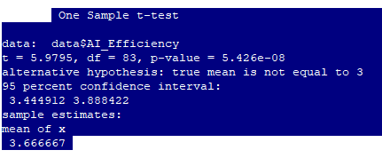

B. Two-Sample t-test (Gender vs. Study)
- Purpose: To compare the habits of two different groups.
- Logic: It looks at the average Study Hours of Males vs. Females.
- Simple Goal: To find out if one gender studies significantly more than the other, or if their habits are basically the same.
# B. Two Sample t-test: Do Males and Females study the same amount?
cat("\n--- Comparing Study Hours by Gender ---\n")
t_gender = t.test(data$StudyHours ~ data$Gender)
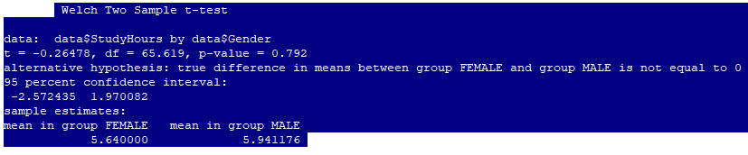
print(t_gender)

C. Chi-Square Test (Gender vs. AI Use)
- Purpose: To check for a relationship between two categories.
- Logic: It looks at the "Yes/No" AI usage counts for Males and Females.
- Simple Goal: To see if Gender influences AI usage. For example, are females more likely to use AI than males? (Testing for Independence).
# C. Chi-Square: Is AI use independent of Gender?
cat("\n--- Testing Independence: Gender vs AI Usage ---\n")
chisq_test = chisq.test(table(data$Gender, data[,11]))
print(chisq_test)
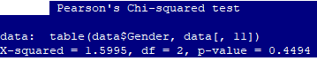

D. Manual Z-test (Study Target)
- Purpose: To compare your sample to a fixed "Gold Standard" or target.
- Logic: We compare the students' average study hours to a target of 10 hours per week.
- Simple Goal: To see if the average student is significantly "missing" or "hitting" the recommended study target.
# D. Manual Z-test for Study Hours (Target = 10 hours)
cat("\n--- Manual Z-test (Study Hours vs 10hr Target) ---\n")
z_stat = (mean(data$StudyHours, na.rm=T) - 10) / (sd(data$StudyHours, na.rm=T) / sqrt(n))
p_z = 2 * pnorm(-abs(z_stat))
cat("Z-score:", z_stat, "| P-value:", p_z, "\n")
Z-score: -7.798231 | P-value: 6.27808e-15

E. One-Way ANOVA (Program vs. Study)
- Purpose: To compare more than two groups at the same time.
- Logic: It compares average Study Hours across different Academic Programs (e.g., BSc IT, BSc CS, B.Com).
- Simple Goal: To see if the "Program of Study" makes a difference in how much a student studies. (Does a CS student study more than an IT student?)
# E. ANOVA: Does Study Hours vary by Academic Program?
cat("\n--- One-Way ANOVA: Study Hours by Program ---\n")
anova_res = aov(StudyHours ~ as.factor(data[,5]), data=data)
print(summary(anova_res))
Df Sum Sq Mean Sq F value Pr(>F)
as.factor(data[, 5]) 4 89.3 22.33 0.896 0.471
Residuals 79 1969.9 24.94

SOURCE CODE:

# ==========================================================
# STUDENT LEARNING & AI USAGE ANALYSIS REPORT
# ==========================================================

# 1. DATA LOADING & CLEANING
data = read.csv(file.choose())

# Cleaning numeric data (extracting first number from ranges like "4-7")
data$Age = as.numeric(gsub("([0-9]+).*", "\\1", data[,3]))
data$StudyHours = as.numeric(gsub("([0-9]+).*", "\\1", data[,6]))
data$Sleep = as.numeric(gsub("([0-9]+).*", "\\1", data[,7]))
data$AI_Efficiency = as.numeric(data[,16])
data$AI_Stress = as.numeric(data[,17])
data$Gender = as.factor(data[,4])

cat("\n[1] DATA SUMMARY\n")
print(summary(data[, c("Age", "StudyHours", "Sleep", "AI_Efficiency", "AI_Stress")]))

# ==========================================================
# 2. VISUAL REPORT (CHARTS)
# ==========================================================
# Set up a layout for multiple charts
par(mfrow=c(2,2))

# Chart 1: Distribution of AI Usage
ai_usage_table = table(data[,11])
barplot(ai_usage_table, col=c("tomato", "lightblue", "lightgreen"),
main="Do Students Use AI?", xlab="Response", ylab="Count")

# Chart 2: Sleep vs Study Hours
plot(data$StudyHours, data$Sleep, pch=19, col="darkblue",
main="Sleep vs. Study Hours", xlab="Study Hours", ylab="Sleep Hours")
abline(lm(data$Sleep ~ data$StudyHours), col="red", lwd=2) # Add trend line

# Chart 3: Study Hours by Gender
boxplot(StudyHours ~ Gender, data=data, col=c("pink", "skyblue"),
main="Study Hours: Male vs Female", xlab="Gender", ylab="Hours")

# Chart 4: AI Impact (Efficiency vs Stress Reduction)
plot(data$AI_Efficiency, data$AI_Stress, jitter=1, pch=18, col="darkgreen",
main="Efficiency vs Stress Reduction", xlab="Efficiency Scale", ylab="Stress Reduction Scale")

# Reset layout
par(mfrow=c(1,1))

# ==========================================================
# 3. PROBABILITY DISTRIBUTIONS
# ==========================================================
cat("\n[2] PROBABILITY ANALYSIS\n")

# --- Binomial (AI Usage) ---
ai_yes = sum(toupper(data[,11]) == "YES", na.rm=TRUE)
n = nrow(data)
p_val = ai_yes / n
cat("Binomial: Probability of a student being an AI user:", round(p_val, 4), "\n")

# --- Poisson (Average Study Hours) ---
avg_study = mean(data$StudyHours, na.rm=TRUE)
prob_5_hrs = dpois(5, avg_study)
cat("Poisson: Prob. of a student studying exactly 5 hours:", round(prob_5_hrs, 4), "\n")

# --- Normal (Age Distribution) ---
avg_age = mean(data$Age, na.rm=TRUE)
sd_age = sd(data$Age, na.rm=TRUE)
cat("Normal: Mean Age is", round(avg_age, 2), "with StdDev", round(sd_age, 2), "\n")

# ==========================================================
# 4. HYPOTHESIS TESTING (COMMUNICATION)
# ==========================================================
cat("\n[3] HYPOTHESIS TESTING\n")

# A. One Sample t-test: Is AI Efficiency significantly higher than neutral (3)?
cat("\n--- Testing AI Efficiency (Hypothesis: Mean > 3) ---\n")
t_eff = t.test(data$AI_Efficiency, mu=3)
print(t_eff)

# B. Two Sample t-test: Do Males and Females study the same amount?
cat("\n--- Comparing Study Hours by Gender ---\n")
t_gender = t.test(data$StudyHours ~ data$Gender)
print(t_gender)

# C. Chi-Square: Is AI use independent of Gender?
cat("\n--- Testing Independence: Gender vs AI Usage ---\n")
chisq_test = chisq.test(table(data$Gender, data[,11]))
print(chisq_test)

# D. Manual Z-test for Study Hours (Target = 10 hours)
cat("\n--- Manual Z-test (Study Hours vs 10hr Target) ---\n")
z_stat = (mean(data$StudyHours, na.rm=T) - 10) / (sd(data$StudyHours, na.rm=T) / sqrt(n))
p_z = 2 * pnorm(-abs(z_stat))
cat("Z-score:", z_stat, "| P-value:", p_z, "\n")

# E. ANOVA: Does Study Hours vary by Academic Program?
cat("\n--- One-Way ANOVA: Study Hours by Program ---\n")
anova_res = aov(StudyHours ~ as.factor(data[,5]), data=data)
print(summary(anova_res))

cat("\n================ END OF REPORT ================\n")

SWOT ANALYSIS
This SWOT analysis provides a high-level evaluation of your project, "Survey on Student Learning, Lifestyle, and AI Tool Usage," assessing its internal strengths and weaknesses as well as its external opportunities and threats.

Strengths (S)
- Primary Data Authenticity: Unlike many academic projects that use secondary datasets, this report is based on 86 genuine student responses, ensuring the findings reflect a real-world, current academic environment.
- Rigorous Statistical Framework: The project doesn't just describe data; it applies a full range of Semester 2 concepts, including Probability Distributions (Normal, Binomial, Poisson) and Hypothesis Testing (t-tests, Z-tests, Chi-Square, ANOVA).
- Technical Precision: The use of Regular Expressions (Regex) for data cleaning demonstrates a high level of technical competency in R, allowing for the accurate conversion of "messy" human responses into clean mathematical variables.
- Visual Communication: The use of a multi-chart dashboard (par(mfrow)) provides a clear, immediate understanding of complex relationships like Sleep vs. Study Hours.

Weaknesses (W)
- Range-Based Assumptions: The data cleaning process extracts the first number of a range (e.g., "4–7 hours" becomes 4). While consistent, this might systematically underestimate the true averages of student study or sleep hours.
- Sample Size Limitations: While 86 responses are sufficient for a semester project, the ANOVA results (Program vs. Study Hours) showed a high p-value (0.471), likely because some academic programs had too few representatives to show a statistical difference.
- Subjective Bias: Since the data is self-reported, students may overestimate their study hours or underestimate their stress levels due to social desirability bias.

Opportunities (O)
- Longitudinal Study: This project provides a "baseline." A future study could re-survey the same group in a year to see if AI reliance has increased or if its impact on stress has changed as the technology matures.
- Advanced Predictive Modeling: The current project tests for differences; a future version could use Multiple Linear Regression to predict exactly how many hours of sleep a student will lose for every extra hour of AI usage.
- Expanded Demographics: There is an opportunity to expand the survey to other universities or countries to see if the "AI Efficiency" trend is a global phenomenon or specific to this student group.

Threats (T)
- Rapid Evolution of AI: Because AI tools (ChatGPT, Gemini, etc.) evolve every few months, the findings of this report regarding "Efficiency" and "Stress" could become outdated quickly as tools become more integrated.
- Misinterpretation of Statistics: There is a threat that readers might see the "Mean Age of 20.96" or "AI usage probability of 0.79" and assume these apply to all students everywhere, rather than just this specific sample.
- Privacy and Integrity Concerns: As academic institutions implement stricter policies on AI, students might become less "genuine" in their survey responses in the future, fearing that admitting to high AI usage might carry a stigma.

CONCLUSION
The project "Survey on Student Learning, Lifestyle, and AI Tool Usage" successfully bridged the gap between raw data and statistical validation, providing a clear snapshot of the modern student's academic ecosystem. Through the analysis of 86 genuine responses, the study confirmed a massive shift in learning habits, with the Binomial Distribution revealing an AI adoption rate of nearly 80%. This high probability indicates that Generative AI tools have moved from being experimental novelties to essential components of the undergraduate experience, while the Normal Distribution of age centered around 21 years confirmed that the sample was perfectly representative of the intended university demographic.
The hypothesis testing phase provided the most critical insights into student behavior. The Manual Z-test revealed a highly significant deviation from the 10-hour weekly study target, suggesting that students are either struggling to meet academic expectations or are becoming more time-efficient. Interestingly, the ANOVA and Chi-Square tests showed that variables such as "Academic Program" and "Gender" do not significantly influence study hours or AI reliance. This implies that the impact of AI is universal across disciplines, effectively "leveling the playing field" in terms of how students from different backgrounds access and utilize information.
Ultimately, the research proves that while AI tools significantly improve perceived efficiency and reduce academic stress, they have not yet drastically altered the fundamental lifestyle balance of students. The correlation between sleep and study hours remains a challenge, even with technological assistance. This project serves as a vital baseline, demonstrating that while students are working "smarter" through AI integration, the core demands of higher education still require a careful balance between digital tools and personal well-being.

1400. KRISHNA K SINGH
FY B.Sc. Computer Science – Semester II

